**Lesson 1:**

Getting Started

Print Statement

Variables and Data Types

Operators

**Getting Started:**

The current version of Python we will use is Python 3.7.

Python comes with 2 user options:

1. An interactive mode “shell” that allows you to test small bits of code or run code easily.



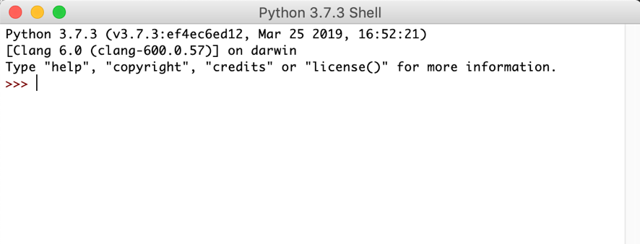

1. A place for writing files:

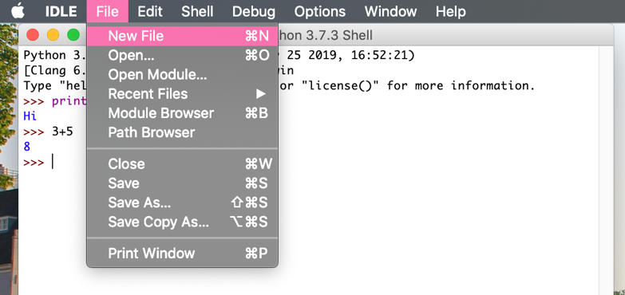



**Print Statement**:

When writing code, it’s helpful to test how your code is working or to print words or symbols to the screen for a user to see/interact with.

print(“Hello World!”)

print(1+2)

**Data Types:**

In computer programming we use different types of data to create programs. In python there are 4 types of data we work with:

1. Integers (whole numbers) int()
2. Floating-Point Numbers (or decimals) float()
3. Strings (text) str()
   1. Represented as any typed text or number surrounded by single or double quotes

“hi” “34” “Hello World”

1. Boolean Values bool() True/False

A Boolean value is true or false

**Variables:**

In math we can represent a value using some variable either x or y. In computer science we can store any data type into a variable for easy use.

x = 5

y = 3

name = “katie”

a_boolean = True

a_float = 3.14

Variable Naming Conventions:

variable_name = data

* The variable name always goes to the left of the data you assign.
* Variable names in python should start lowercase
* Don’t begin a variable name using a number
* If you are using a multi-word name use the underscore: a_variable = 5

a = 5

b = 6

a+b = 11

**Operators**

Computer Science often uses math. To use math in python here are the symbols you use:

Addition is a plus sign 5+4

Subtraction is a dash 5-4

Multiplication is an asterisk or star 5*4

Division is a forward slash 20/4

Powers are represented by two asterisk 22 = 2**2

**Extra Tips**

Type Casting: the ability to change one data type into another

num_string = “5”

num_int = int(num_string)

Testing the data Type with type(): If you don’t know what data type a variable is you can test it using the type( variable name goes here ) function.

Try this out in Python Interactive Shell!

a = 5

type(a)

>this will return ‘int’

**Practice Exercises**

1. Try printing out this shape: *****

|

|

|

1. What are the types of these variables:

a = “my name is katie”

b = 1234

c = 3.4353

d = ‘hello’

e = True

1. Use interactive mode to solve these equations:

(6+7)/(6x6)

(9*2) + (7**3)

100 *3.14

(20/4) +( 32/4) + (6+5)

1. Write a program that has a variable for your name, then prints out “hello my name is” with your name.

Output > Hello my name is Derek